Calculating Sales Commission

Sequence Diagram:

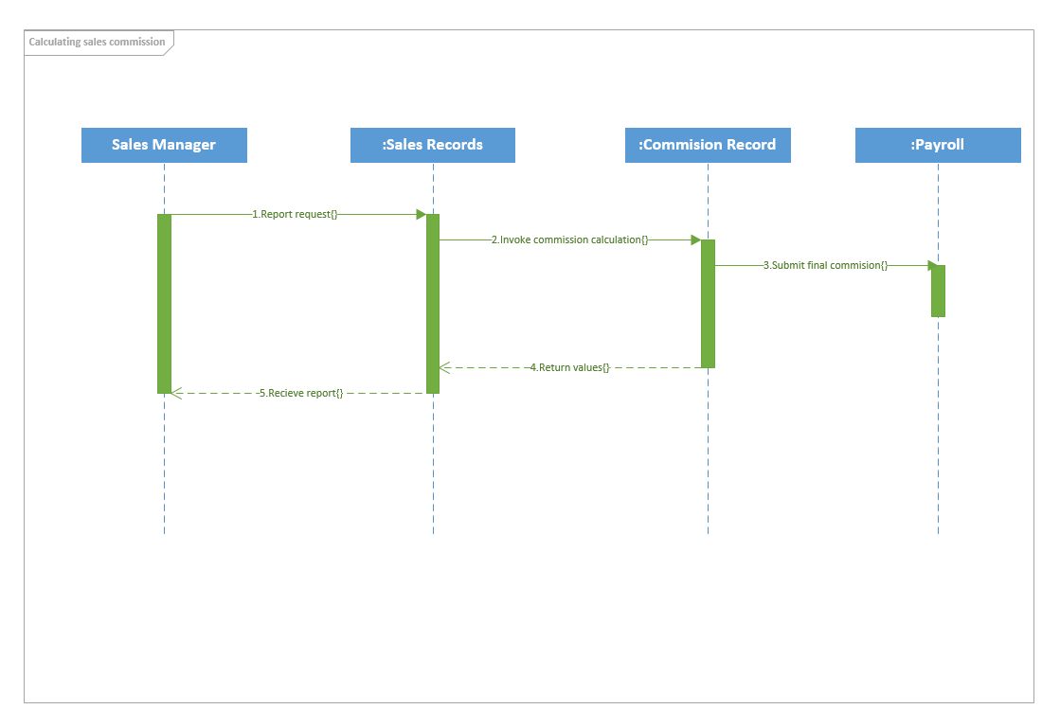

Calculating Sales Commission

Communication Diagram:



3. Final Commission Amount request

2.2. Returned values

2.1. Calculated Commission request

1.2. Report sent

* 1. Report request

:Commission Records

:Sales Records

:Payroll

Sales Manager